**Excel Assignment – 18**

Que.1) What are comments and what is the importance if commenting in any code?

Ans. – Comments are the lines in the code that are ignored while executing the code. These are represented as green text in the code.

The comments help describe the written code. Knowing the correct use of comments is very important because while working with long and complex code, comments help us identify which part of code does what. It is very helpful for development purposes.

Que.2) What is Call Statement and when do you use this statement?

Ans. – Call statement is used to transfers control to a Sub procedure, Function procedure, or dynamic-link library (DLL) procedure.

Que.3) How do you compile a code in VBA? What are some of the problem that you might face when you don’t compile a code?

Ans. – To compile VBA code click on Debug Menu, then Compile VBA Project.

It reviews your code to ensure it „sanitary/clean‟ code. This means it checks that all the required input variables are present, it validates that all required variable declaration are present.

By Compiling your VBA code, minimize runtime errors and crashes are minimised.

Que.4) What are hot keys in VBA? How can you create your own hot keys?

Ans. – After creating macros, using hotkey helps you to run the code quickly in workbook. Hot keys can be created in 2 ways:

# Assign hotkey to specified macro in Excel:

* 1. Click Developer > Macros to open the Macro dialog box.
  2. In the Macro dialog box, select the macro name you will assign hotkey, and then click the Options button.
  3. In the Macro Options dialog box, specify a shortcut key (e.g. „p‟) in the Shortcut key box, and then click the OK button.
  4. Close the Macro dialog box.

From now on, when using the hotkey (in this case I press the Ctrl + p keys), the specified macro will run immediately.

# Assign Hotkey To Specified Macro With VBA Code

1. Open the worksheet you want to run specified macro by hotkey, and then right click the sheet name, choose View Code from the context menu.
2. In the opened Microsoft Visual Basic for Applications window, copy below VBA code into the Code window.

Private Sub Worksheet_SelectionChange(ByVal Target As Range) Application.OnKey "^{RETURN}", "Clear_ButtonActiveSheet" End Sub

1. Then press the Alt + Q keys to close the Microsoft Visual Basic for Applications window. From now on, when pressing Ctrl + Enter keys in the worksheet, the macro named “Clear_ButtonActiveSheet” will run immediately.

Que.5) Create a macro and shortcut key to find the square root of the following numbers 665, 89, 72, 86, 48, 32, 569, 7521

Ans. – Macro Created and Shown on following screenshots:

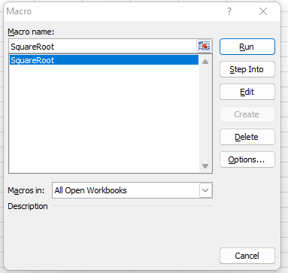

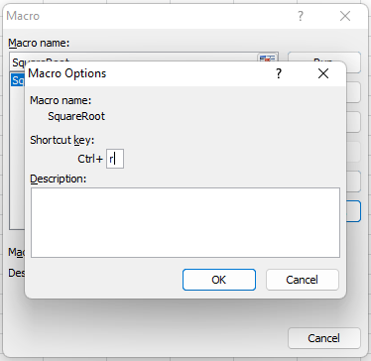

Que.6) What are the shortcut keys used to

a. Run the code

b. Step into the code

c. Step out of code

d. Reset the code

Ans. – Shortcut keys used to:

1. Run the code: F5
2. Step into the code: F8
3. Step out of code: CTRL+SHIFT+F8
4. Reset the code: F9